- Copyright for test papers and marking guides remains with West Australian Test Papers.
- The papers may only be reproduced within the purchasing school according to the advertised conditions of sale.
- Test papers must be withdrawn after use and stored securely in the school until October 12th.
HUMAN BIOLOGY
UNITS 3 & 4
2023
MARKING GUIDE

Insert School Logo

Name: _______________________________________________________

Teacher: ___________________________________________________

Time allowed for this paper

Reading time before commencing work: ten minutes
Working time: three hours

Materials required/recommended for this paper
To be provided by the supervisor
This Question/Answer booklet
Multiple-choice answer sheet

To be provided by the candidate
Standard items: pens (blue/black preferred), pencils (including coloured), sharpener, correction fluid/tape, eraser, ruler, highlighters

Special items: up to three calculators, which do not have the capacity to create or store programmes or text, are permitted in this ATAR course examination

Important note to candidates
No other items may be taken into the examination room. It is your responsibility to ensure that you do not have any unauthorised material. If you have any unauthorised material with you, hand it to the supervisor before reading any further.

Section One: Multiple-choice 30% (30 Marks)

Question | Solution
1 | C
2 | A
3 | D
4 | A
5 | D
6 | B
7 | B
8 | B
9 | B
10 | B
11 | A
12 | C
13 | D
14 | B
15 | D
16 | C
17 | C
18 | A
19 | D
20 | A
21 | D
22 | D
23 | C
24 | C
25 | A
26 | C
27 | D
28 | A
29 | A
30 | C

Section One: Multiple-choice 30% (30 Marks)

This section has 30 questions. Answer all questions on the separate Multiple-choice answer sheet provided. For each question shade the box to indicate your answer. Use only a blue or black pen to shade the boxes. Do not use erasable or gel pens. If you make a mistake, place a cross through that square, then shade your new answer. Do not erase or use correction fluid/tape. Marks will not be deducted for incorrect answers. No marks will be given if more than one answer is completed for any question.

Suggested working time: 40 minutes.

1. The cerebellum

(a) is involved in memory and learning.
(b) would control temperature and sleeping patterns.
(c) ensures movements are smooth and controlled.
(d) connects parts of the brain and spinal cord with each other.

2. Which of the following statements is correct? In general,

(a) the nervous system is more specific than the endocrine system.
(b) the endocrine system targets one effector at a time.
(c) messages in the nervous system have a longer persistence.
(d) the endocrine system outcomes are short lived.

Question 3 refers to the incomplete table below.

Type of Immunity | Artificial Immunity | Natural Immunity
Active Immunity | 1 | Someone catches a disease from their friend
Passive Immunity | A person is injected with antivenom after a snakebite | 2

3. Which of the following statements would be correct?

(a) 2 – A baby is vaccinated against measles, mumps and diphtheria.
(b) 1 – Someone is injected with an antibody.
(c) 2 – A 3 month old is given an antigen by its mother during breastfeeding.
(d) 1 – A person is given a subunit vaccine.

Questions 4, 5 and 6 refer to the image below showing glands of the human body.

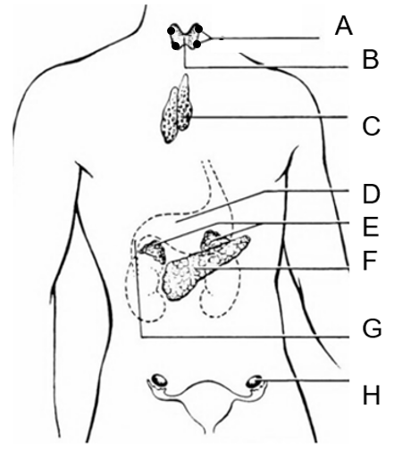

4. An overproduction of hormone from Structure B

(a) would result in an intolerance to heat.
(b) is called hypothyroidism.
(c) would cause an increase in the release of TSH.
(d) can be treated by iodine supplements.

5. Structure A

(a) releases its hormone due to the release of ACTH from the anterior pituitary.
(b) releases a hormone that regulates the levels of sodium and potassium in the blood.
(c) produces PTH due to nervous stimulation by the hypothalamus.
(d) regulates the amount of calcium in the blood.

6. The thymus

(a) contains cells that forms part of the antibody mediated immune response.
(b) is labelled structure C and produces a hormone that matures T cells.
(c) is involved in a hormone cascade that regulates body metabolism.
(d) produces TSH.

Questions 7 and 8 refer to the image below of a hominin skull.
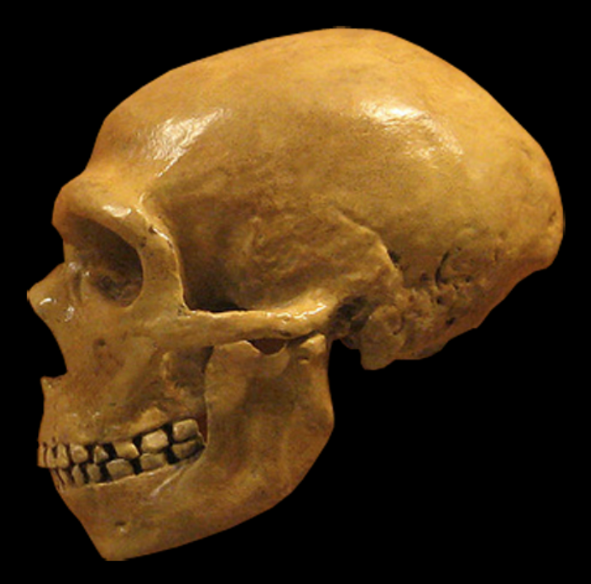

7. This hominin

(a) is Homo erectus due to its heavy brow ridges and large prognathism.
(b) would have lived around 300,000 to 50,000 years ago.
(c) was the first to create hand axes.
(d) had a cranial capacity of about 800cc.

8. Compared to other primates, hominins such as these

(a) would have a smaller cranial capacity than the other primates.
(b) have longer thumbs and shorter fingers than the other primates.
(c) have adaptations suited for an arboreal lifestyle.
(d) have greater prognathism and more teeth than the other primates.

9. Which of the following statements about the divisions of the nervous system is correct?

(a) The somatic nervous system can only contain motor neurons.
(b) The parasympathetic division contains two neurons in a chain in its nerve pathway.
(c) Sensory neurons use the neurotransmitter noradrenalin in the afferent nervous division.
(d) The autonomic nervous system forms part of the afferent nervous division.

Question 10 and 11 refer to the image below of a tool used by hominins.

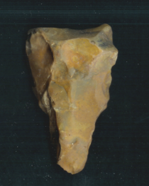

10. This type of tool

(a) is a hand axe that was first created by Homo habilis.
(b) would have been made by Homo erectus.
(c) belongs to the Oldowan tool industry.
(d) is older than 2 million years of age.

11. Tools such as these typically show

(a) more flaking than older tools.
(b) larger size than older tools.
(c) more variety in materials than younger tools.
(d) greater specialisation than younger tools.

12. Hypercalcaemia occurs when calcium levels in the blood are too high. This condition would

(a) occur as a result on the surgical removal of the parathyroid glands.
(b) stop the release of neurotransmitters from axon terminals.
(c) cause more calcitonin to be released.
(d) prevent the gut from absorbing calcium or the kidney from excreting it.

13. All of the following about carbon dioxide are correct except one. Which one is incorrect?

(a) Carbon dioxide impacts the medulla oblongata to stimulate breathing.
(b) Carbon dioxide levels are markedly reduced during hyperventilation.
(c) Carbon dioxide dissolves in blood plasma to form bicarbonate ions.
(d) Carbon dioxide levels have the same effect on breathing rate as oxygen levels.

Question 14 and 15 refer to the image below which shows core samples taken from one site.
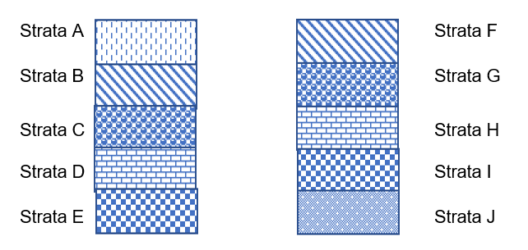

14. Strata D is

(a) older than Strata H.
(b) older than Strata F.
(c) younger than Strata C.
(d) younger than Strata G.

15. All of the following statements about these core samples are correct except one. Which one is incorrect?

(a) They rely on superposition to age fossils found in them.
(b) They have to be from different areas in order to date fossils through correlation of rock strata.
(c) In the layers, index fossils such as pollen could be used to date specimens.
(d) By comparing the layers, they will give an estimated age in years of specimens found in them.

16. A student collected four speeds of nerve transmission at 37ºC and 20ºC. The data in metres/second for 37ºC were: 2.51 2.47 2.31 2.52

Which of the following is correct?

(a) The student should graph the data for 37ºC and 20ºC using a bar graph.
(b) The mean for the 37ºC data is 2.45 metres/second.
(c) The median for the 37ºC data is 2.49 metres/second.
(d) The y axis of the graph for the 37ºC and 20ºC data is Temperature (ºC).

Question 17 refers to the image below of the standard distribution of cranium circumference
size in centimetres for newborns in 2023.
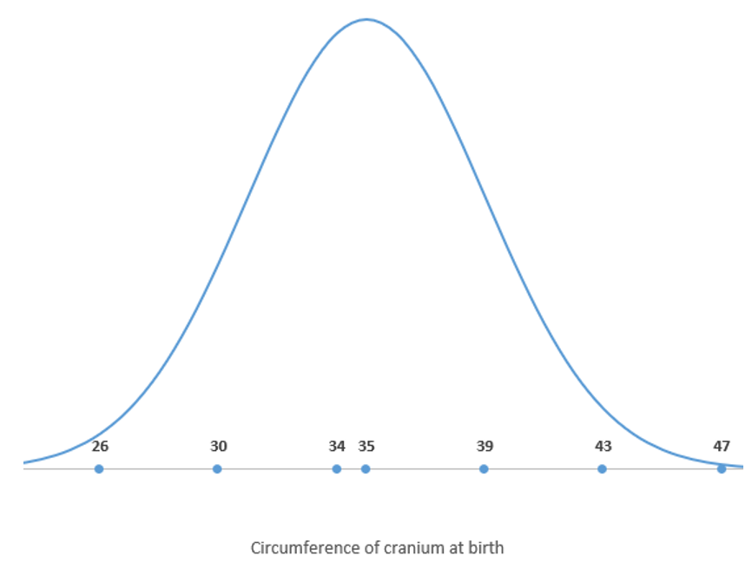

17. What could be expected for the cranium circumference of Homo neanderthalensis newborns?

(a) a taller, narrower curve with a mean of 35 cm
(b) a shorter broader curve with a mean of 35 cm
(c) a similar sized and shaped curve with a mean greater than 35 cm
(d) a similar sized and shaped curve with a mean less than 35 cm

18. Homo neanderthalensis

(a) were the first to bury their dead.
(b) only made tools out of stone.
(c) did not build shelters.
(d) created mural art.

19. Which of the following statements about radiocarbon dating is correct?

(a) It could be used on a stone tool older than 100,000 years.
(b) It relies on a half-life of 1300 million years.
(c) It utilises the breakdown of carbon 12 to carbon 14.
(d) It could be used on a wooden handle if it was younger than 70,000 years.

Question 20 and 21 refer to the skull below.
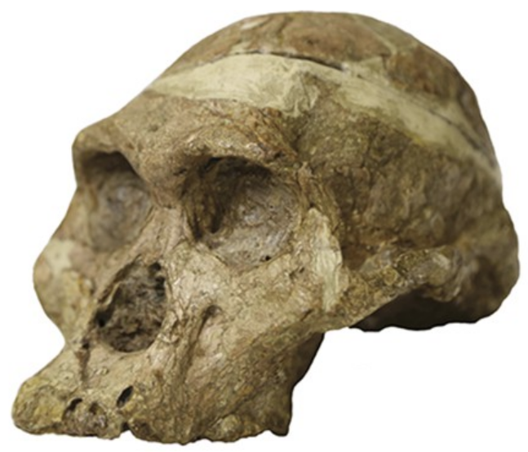

20. This individual is

(a) Australopithecus africanus.
(b) Paranthropus robustus.
(c) Homo habilis.
(d) Homo erectus.

21. This individual

(a) would be found in Europe and Asia.
(b) created tools made of bone.
(c) moved out of Africa as a nomadic hunter gatherer.
(d) had large molars and premolars.

22. The following is a list of characteristics of pathogens.

i) cell wall
ii) slime layer
iii) RNA or DNA
iv) protein coat
v) plasmids
vi) no nucleus

Which of these characteristics would be seen in bacteria?

(a) iv), v), vi)
(b) i), iii), vi)
(c) ii), iv), v)
(d) i), ii), vi)

23. “River blindness” is caused by a parasitic worm that is transmitted by the bite of blackflies. What is the mechanism of transmission for river blindness?

(a) direct contact
(b) droplets
(c) vector
(d) airborne

24. T cells and B cells

(a) are part of the second layer of defence.
(b) can be stimulated by a macrophage.
(c) are created in bone marrow.
(d) create antibodies.

25. Antibodies can act in all of the following ways, except one. Which one is incorrect?

(a) enhance the antigen’s reaction with other cells
(b) make soluble substances insoluble
(c) dissolve antigens
(d) bind to viral surfaces to prevent them entering cells

26. Non-disjunction

(a) occurs during mitosis.
(b) is a gene mutation.
(c) includes conditions such as Klinefelter’s syndrome.
(d) always results in more chromosomes in the daughter cell.

27. Variation does not

(a) occur due to sexual reproduction.
(b) result in changes in allele frequency in different populations.
(c) contribute to natural selection in populations.
(d) cause random assortment or crossing over.

28. Germ line mutations

(a) can be passed on to offspring.
(b) occur in the body cells of the affected individual.
(c) and somatic mutations do not affect offspring of affected individuals.
(d) include skin cancers.

29. A bottleneck event

(a) occurred on Pingelap Island in Micronesia after a typhoon.
(b) occurred on Pitcairn Island when the mutineers of the Bounty landed there.
(c) results in a much larger population than before the event.
(d) causes an immediate increase in the genetic diversity of the affected population.

30. On a small, isolated island in the Atlantic Ocean, the inhabitants had never been exposed to measles. When the island was first visited by European explorers, nearly half the population died of measles, while none of the Europeans died. A second wave of measles affected the island population about 10 years later. This time, only 8% of the population died. Since then, there have been no deaths from measles.

Which of the following statements is incorrect?

(a) The islanders showed a primary response in the first wave of infection.
(b) The Europeans had memory cells for measles when they reached the island.
(c) Any islanders who caught measles in the second wave would not have had memory cells for measles.
(d) The symptoms of measles would have been less severe in those infected again in the second wave of infection.

End of Section One

Section Two: Short answer 50% (106 Marks)

This section has seven questions. Answer all questions. Write your answers in the spaces provided.

Supplementary pages for planning/continuing your answers to questions are provided at the end of this Question/Answer booklet. If you use these pages to continue an answer, indicate at the original answer where the answer is continued, i.e. give the page number.

Suggested working time: 90 minutes.

Question 31 (12 marks)
A group of Year 12 students decided to test the effect of sleep on reaction time. They asked three of their classmates to take part in the study. All three subjects were asked to complete an online reaction test before they went to bed at 10pm. One subject was allowed 2 hours sleep, another 4 hours and the last was allowed 8 hours sleep. All subjects were tested with the same online reaction test at 9am the following day.
In the online reaction test subjects had to click a button whenever they saw an animal leave its herd and run across the screen. Five animals ran at some point in each test and the average reaction time for all 5 animals was shown on the screen. If the button was clicked before an animal moved, a 0.5 second penalty was added to the students’ reaction time.
(a) What hypothesis could the students be testing? (1 mark)
Description | Marks
Hypothesis in an appropriate format (eg: must not be a question, must not have an “and”, be precisely written, testable statement)  Eg: If a person has more sleep then their reaction times will be faster | 1
Total | 1

(b) Name the dependent variable. (1 mark)
Description | Marks
Reaction time | 1
Total | 1

(c) Identify two controlled variables. (2 marks)
Description | Marks
All students are from the same class | 1-2
All completed a reaction time test before bed
All subjects were tested at 9am after sleep
The reaction test itself was the same for all subjects
Total | 2

(d) Draw up a table of results for their experiment. (3 marks)

Description | Marks
Title: Effect of sleep on reaction time | 1-3
Heading: Amount of sleep (hrs) and 2,4,8 units
Heading: Average reaction time (sec)
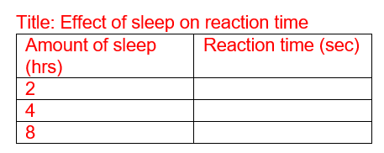

Total | 3

(e) Using evidence, comment on the reliability of their experiment and suggest how reliability can be improved in any experiment. (3 marks)

Description | Marks
Reliability was poor / low | 1-3
As only 1 subject was used for each condition of sleep
Repeat the experiment / increase the number of subjects / trials
Total | 3

(f) Afterwards the students discussed the validity of their experiment. They agreed they should have told their subjects what they were allowed to eat during it. Explain why failing to tell the subjects what they were allowed to eat may have affected validity.
(2 marks)
Description | Marks
Food / drink may have contained caffeine / sugar / stimulants | 1-2
Which would have been an uncontrolled variable / not been a fair test
Total | 2

Question 32 (14 marks)
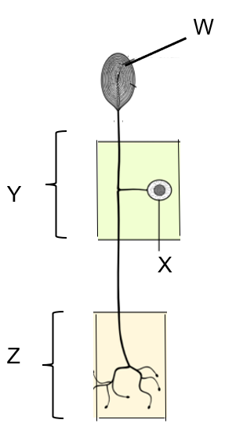

(a) Identify the type of neuron in the diagram. (1 mark)

Description | Marks
Sensory / unipolar | 1
Total | 1

(b) This neuron is part of a reflex arc. What is the structural classification of a neuron it would synapse with in region Z? (1 mark)

Description | Marks
Multipolar (do not accept connector/interneuron) | 1
Total | 1

(c) What structures are represented by labels W and Y? (2 marks)

Description | Marks
W – receptor  Y – dorsal/posterior root ganglion | 1-2
Total | 2

(d) What type of matter is structure X always found in? (1 mark)

Description | Marks
Grey | 1
Total | 1

(e) Reflexes are fast, automated and stereotyped. Explain the reasons for each of these characteristics. (3 marks)

Description | Marks
Fast – does not require the brain involvement to coordinate a response | 1-3
Automated – is an unconscious/involuntary action
Stereotyped – the same response will occur for the same stimulus each time
Total | 3

(f) Explain how the action potential is transferred across the synapse. (6 marks)

Description | Marks
An action potential causes calcium channels to open and calcium ions to move into the axon terminal | 1-6
Calcium causes vesicles containing neurotransmitters to migrate to the surface of the axon terminal / pre-synaptic membrane
Neurotransmitters are released into the synapse through exocytosis
Which diffuse across the synapse
And contact / bind with receptors on the post-synaptic neuron / membrane
Which causes an action potential to begin in the post-synaptic neuron
Total | 6

Question 33 (17 marks)
The following image shows a hormone cascade.
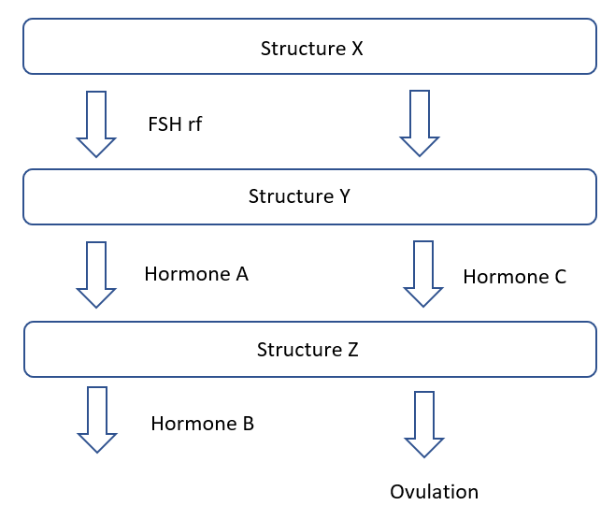

(a) Name structures X and Z. (2 marks)

Description | Marks
X – Hypothalamus | 1-2
Z – Ovary
Total | 2

(b) Explain how structure X communicates with structure Y. (1 mark)

Description | Marks
Using hormones through the bloodstream / blood circulation | 1
Total | 1

(c) Hormone A and Hormone B have different modes of action. Compare and contrast their modes of action. (5 marks)

Description | Marks
Any 2 contrasts, max 4 marks, pair must match
FSH – receptor in/on cell membrane  Hormone B – Receptors inside cell/in cytoplasm/on organelles/nucleus/genes | 1-4
FSH – uses a secondary messenger
Hormone B – does not use a secondary messenger
FSH – affects enzyme action
Hormone B – affect gene expression
FSH – shorter lasting effect
Hormone B – longer lasting effect
Both use receptors/travel through the bloodstream/affect target cells | 1
Total | 5

(d) State the effect of Hormone C in males. (1 mark)
Description | Marks
Makes testosterone | 1
Total | 1

(e) Hormone A is made synthetically and given to women undergoing in-vitro fertilisation. Name the process that would be used to make Hormone A in this way and describe the role of the chemicals required for this process to take place. (7 marks)

Description | Marks
Recombinant DNA / genetic engineering | 1-7
Restriction enzyme
Used to cut the plasmid and gene of interest
To produce sticky ends
So DNA can be recombined
DNA ligase
Used to join the two forms of DNA together
Total | 7

(f) Structure Y also controls the amount of sodium and potassium in the blood. Explain how Structure Y is able to do this. (1 mark)

Description | Marks
Releases ACTH which causes the release of aldosterone | 1
Total | 1

Question 34 (9 marks)
Gel electrophoresis is often used to identify different lengths of DNA. In the same way, it can also be used to identify the different amino acids that form parts of a protein, as the different amino acids have different lengths.
(a) At which electrode would you find the longest amino acid chains on an agarose gel?
(1 mark)

Description | Marks
Black/ negative | 1
Total | 1

(b) The amino acid sequence of cytochrome C was studied in this way in order to determine the degree of relationship between different species. What is the term given to proteins like cytochrome C that are found in many species? (1 mark)

Description | Marks
Ubiquitous proteins | 1
Total | 1

The same portion of cytochrome C protein of four different species was placed on an agarose
gel and the results are tabulated below.

Species | Amino acid A | Amino acid B | Amino acid C | Amino acid D
1 | Ala | Gly | Arg | Lys
2 | Arg | Val | Pro | Lys
3 | Ala | Gly | Lys | Lys
4 | Pro | Gly | Arg | Asn

(c) Which two species are most closely related? (1 mark)

Description | Marks
Species 1 and 3 | 1
Total | 1

(d) A student created a phylogenetic tree based on this data, which is shown below.
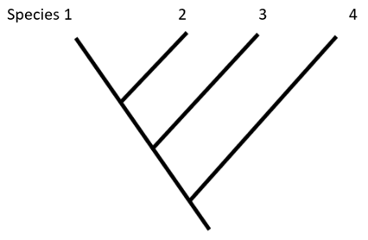

Explain whether this phylogenetic tree is correct. (2 marks)

Description | Marks
No it is not correct | 1
As it shows species 1 and 2 as the most closely related species which is incorrect | 1
As it shows species 1 and 2 more closely related than 1 and 3
Total | 2

(e) Further study indicated that a mutation had occurred in Species 4. The DNA codon of amino acid D that generated Lys was AAG while the amino acid Asn is determined by the codon AAT. Classify this type of mutation. (1 mark)
Description | Marks
Point mutation / substitution mutation | 1
Total | 1

(f) Name two mutagens and explain the effect of any mutagen. (3 marks)

Description | Marks
X-rays / ultraviolet radiation/ radioactive waste / ionising radiation / cosmic rays | 1-2
Mustard gas / formaldehyde / sulfur dioxide / some antibiotics
Increases the chance of mutations occurring | 1
Total | 3

Question 35 (19 marks)
Sickle cell anaemia is a genetic condition that affects the shape of red blood cells and has a different rate of incidence in different populations.
(a) Discuss how selection pressures and gene flow would have altered the frequency of sickle cell disease in different populations. (6 marks)

Description | Marks
Selection pressure is malaria | 1
Which provides a selective advantage to heterozygotes to survive malaria | 1
Homozygous recessive individuals die from sickle cell anaemia | 1
Homozygous dominant individuals survive sickle cell but die from malaria | 1
Gene flow brings sickle cell allele into new populations | 1
So frequency of sickle cell will be increased | 1
Total | 6

(b) The incidence of sickle cell anaemia is a good case study for the process of natural selection. What is natural selection? (2 marks)

Description | Marks
The process whereby factors in the environment confer a selective advantage | 1
on specific phenotypes to enhance survival and reproduction | 1
Total | 2

(c) Explain how isolation contributes to speciation in a population. (4 marks)

Description | Marks
Can increase or decrease allele frequency of different characterisitics | 1
Due to random genetic drift or founder effect | 1
As gene flow is limited / no gene flow can occur | 1
And new species can be formed | 1
Total | 4

(d) For those heterozygous for sickle cell disease, dehydration can often trigger a sickle crisis. Explain how water conditions are normally maintained in our body. (5 marks)

Description | Marks
High osmotic pressure detected by osmoreceptors in the hypothalamus | 1-5
Which causes the release of ADH from the posterior pituitary
Which causes the distal convoluted tubule and collecting duct to become more permeable to water
So less urine is produced / more water is reabsorbed from the filtrate
And stimulates the thirst centre to increase drinking behaviour
Total | 5

(e) It was suggested that gene therapy could be used to treat sickle cell anaemia. Give one reason why gene therapy would be a good candidate as a treatment for this condition and one reason why it would not be. (2 marks)

Description | Marks
Positive – sickle cell is a monogenic condition / single gene disorder | 1
Negative – difficult to access tissue to insert the new gene | 1
Negative – continual replacement would be required over time
Total | 2

Question 36 (20 marks)
Lee and Vinuesa observed the rapid rise in autoimmune diseases such as lupus, diabetes, multiple sclerosis and inflammatory bowel disease over the last 40 years and decided to study the DNA sequence of people suffering from these conditions. They indicated that where once half a dozen DNA variants were known to trigger inflammatory bowel disease, now, due to bioinformatics, over 250 variants are known.
(a) Define bioinformatics and explain how it would have contributed to the knowledge base about autoimmune diseases. (2 marks)

Description | Marks
Field of biology, computer science, mathematics and information technology that interprets and analyses biological data | 1
Used to compare the DNA of individuals in order to find variations in the DNA sequence for those suffering from autoimmune diseases | 1
Total | 2

(b) PCR was a crucial part of Lee and Vinuesa’s study. Give a reason why PCR was required and explain what substances are needed in order for it to be conducted. (5 marks)

Description | Marks
PCR was required in order to copy the DNA of those with autoimmune diseases | 1
Restriction enzymes cut out the gene of interest | 1
Taq / DNA polymerase builds copies of DNA by attaching nitrogen bases | 1
Primer binds to the separated DNA to indicate where replication begins | 1
Nitrogen bases required to make copies of the DNA | 1
Total | 5

(c) Differentiate between Type I and Type II diabetes. (4 marks)

Description | Marks
Any 2 contrasts, max 4 marks, pair must match
Type I – unable to produce insulin  Type II – unable to produce sufficient insulin / not so responsive to insulin | 1-4
Type I – due to autoimmune condition / genetics
Type II – due to lifestyle factors / overweight / sedentary lifestyle
Type I – begins in childhood / early onset
Type II – begins in older people / late onset
Type I – develops quickly / develops in a few weeks
Type II – develops slowly / develops over years
Type 1 – more severe symptoms
Type II – less severe symptoms
Type I – treatment is injection / pump delivering insulin
Type II – treatment is lose weight / exercise / low carbohydrate diet
Total | 4

(d) Untreated diabetes can result in neuropathy in the extremities, where inflammation and damage to sensory neurons result in pain. Name the receptors capable of detecting pain and state the main way in which they are different to all other types of receptors. (2 marks)

Description | Marks
Nociceptors | 1
Do not adapt / will not become less aware of pain over time | 1
Total | 2

(e) Multiple sclerosis results in the destruction of myelin. Explain how an action potential would normally be transmitted through a myelinated neuron. (7 marks)

Description | Marks
Positive outside negative inside axon / -70mV at rest in the node of Ranvier | 1
Stimulus large enough to break threshold / 15mV causes voltage gated sodium channels to open and sodium ions to move into the neuron | 1
This causes depolarisation in the node of Ranvier | 1
Which triggers the sodium gates in the next node to open | 1
Repolarisation occurs as sodium gates close, potassium gates open and potassium moves out of the neuron | 1
Hyperpolarisation occurs as potassium gates close and sodium potassium pumps bring the membrane back to resting potential / -70mV | 1
The action potential jumps from node to node / saltatory conduction occurs | 1
Total | 7

Question 37 (15 marks)
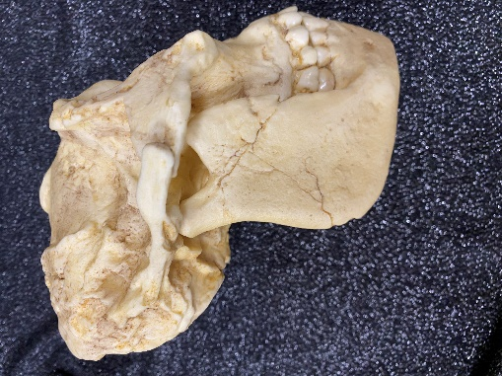
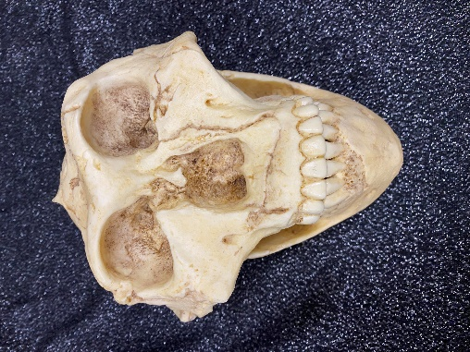

The individual shown in the two images above was dated at approximately 2 million years of age.
(a) Name this species. (1 mark)

Description | Marks
Paranthropus robustus | 1
Total | 1

(b) (i) State the anatomical feature this individual has that is not shared by any other
hominin. (1 mark)

Description | Marks
Sagittal crest | 1
Total | 1

(ii) Explain how this feature would have become more common in this population over time. (7 marks)
Description | Marks
Variation in the presence of a sagittal crest would have existed in the population | 1
There would be a struggle for existence in getting nutrients out of food | 1
Those with the crest would have been able to access more nutrients from the food they ate through stronger chewing | 1
and would have survived and reproduced (survival of the fittest) | 1
Passing on the allele for sagittal crest to their offspring | 1
Those without the sagittal crest would have died or failed to reproduce | 1
So over time the population would have become more alike with a sagittal crest | 1
Total | 7

(c) Homo sapiens has been found throughout the world but is believed to have originated in Africa.

(i) State the anatomical structure present in this species that is not present in any other hominin and suggest the advantage of having such a structure.
(2 marks)

Description | Marks
Well-developed chin | 1
Allows complex speech | 1
Total | 2

(ii) State two different cultural aspects of Homo sapiens (Cro magnon) that set it apart from other hominins. (2 marks)

Description | Marks
Created art / murals / portable art | 1-2
Used bone and antler to make tools
Created blade tools
Developed the burin
Total | 2

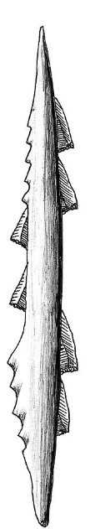
(iii)

This tool was found with a Homo sapiens (Cro magnon) specimen in a cave in France. State the tool culture this tool would have been classified as and give one use of such a tool. (2 marks)
Description | Marks
Magdelanian | 1
Spear hunting game / spear fishing / harpooning (other answers acceptable) | 1
Total | 2

End of Section Two

Section Three: Extended answer 20% (40 Marks)

Question 38 (20 marks)

Aisha went outside to do some trimming in the garden and noticed a small cut on her finger as she put her gloves on. Later that afternoon when she cleaned up she noticed the cut’s appearance had changed.
(a) Describe the changes in appearance Aisha would have noticed and provide an explanation for these changes. (10 marks)

Description | Marks
Inflammation is occurring | 1
Mast cells release histamine and heparin | 1
Histamine causes blood vessels to dilate and become more permeable | 1
Vasodilation brings more blood to the area | 1
So area feel hots | 1
And the skin appears red | 1
Increased permeability means more fluid leave the capillaries and enters the interstitial fluid | 1
So area becomes swollen | 1
Pain is felt | 1
as extra fluid / damage stimulates pain receptors / nocireceptors | 1
Total | 10

(b) Later that night, Aisha started feeling cold and unwell, so she went to bed early. Describe how and why fever occurs and explain what type of immunity this process provides. (10 marks)

Description | Marks
When inflammation occurs, leucocytes release interleukin / prostaglandins / pyrogens | 1
Hypothalamus detects these chemicals and resets the optimal core body temperature to reset to a higher temperature | 1
So people feel cold as their current temperature is far below the new optimal | 1
Shivering and vasoconstriction will occur to generate heat and prevent heat loss | 1
Which increases the core body temperature | 1
When fever breaks the optimum core body temperature is reset back to 37ºC | 1
So people feel hot as their current temperature is far above the normal optimal | 1
Sweating and vasodilation will occur to lose heat | 1
Reduces growth of bacteria / kills bacteria | 1
Offers Internal non-specific immunity | 1
Total | 10

Question 39 (20 marks)

Due to the wind and waves, Oliver capsized his small boat and fell into the cold ocean water. He could only tread water while he watched his boat sink.
(a) Discuss the mechanisms of heat transfer which would have resulted in Oliver losing heat when he was in the water. (6 marks)

Description | Marks
Convection | 1
Movement of wind / water will take heat away from his body | 1
Radiation | 1
Heat lost without contact from his head to the surrounding air | 1
Conduction | 1
Cold water in contact with his skin would cause heat to be lost from his body | 1
Total | 6

(b) Body temperature can be regulated using both nervous and endocrine methods. Describe both of these physiological mechanisms that would have been employed in response to his situation in order to maintain his temperature homeostasis. (10 marks)

Description | Marks
Decreased core body temperature would be detected by thermoreceptors in skin and hypothalamus | 1
Hypothalamus would send nerve impulses through the efferent nervous system | 1
Effectors of skeletal muscles and smooth muscles of the arterioles of the skin | 1
Would produce responses of shivering which increases heat production | 1
and vasoconstriction which would reduce heat loss | 1
TSHrf would be released from the hypothalamus | 1
And cause release of TSH from the anterior pituitary | 1
Which would cause thyroxine from the thyroid gland to be released | 1
Which increases the rate of cell respiration / metabolic rate which increases heat production | 1
Feedback would be an increase in core body temperature | 1
Total | 10

(c) In this stressful time, Oliver’s adrenal gland would have released adrenalin. Explain why this could be both advantageous and disadvantageous to Oliver at this time.
(4 marks)

Description | Marks
Advantages:
More blood flow to muscles for keeping afloat | 1-2
Increased glucose in blood for cell respiration
Reduced blood flow to gut to ensure adequate blood in skeletal muscles
Increased heart rate / breathing rate to supply skeletal muscles
Disadvantages:
More blood flow to extremities increases heat loss | 1-2
Through conduction, convection, radiation, evaporation
Total | 4

Unit 4

Question 40 (20 marks)

The earliest fossils of Homo erectus were discovered by a Dutch army surgeon, Eugene Dubois, on the island of Java in 1890. More of these specimens were found throughout Asia, particularly in the caves of Zhoukoudian.

(a) Describe factors that may have contributed to only a few fossil specimens being found on Java and suggest why the number of specimens of Homo erectus found in caves tends to be quite high. (8 marks)

Description | Marks
Forming fossils
Fossilisation is a chance occurrence  Specimens were not covered quickly enough  Decay organisms were present  Scavengers disturbed the specimen before it could be fossilised  Was not left undisturbed long enough  Soils were not sedimentary / too much humus present for fossils to form  Soils aren’t alkaline / too acidic / wet acidic soil contained oxygen | 1-4
Finding fossils
Fossils destroyed by pressure / geological processes / human activity  Fossils aren’t recognised as fossils  Exposed fossils are weathered / eroded | 1-2
Why they are found in caves
Caves were utilised by Homo erectus over many generations which increases chances of finding specimens | 1-2
Reduced exposure to scavengers in caves preserves fossils
Environmental conditions are more stable in caves so destruction of fossils is reduced
Total | 8

(b) Describe the features of Homo erectus that would indicate the species was adapted for bipedalism. (12 marks)

Description | Marks
Any 12 points
Centralised foramen magnum | 1-12
Small nuchal area for neck muscle attachment
Reduced prognathism
S shaped vertebral column with a lumbar curve
Small spinous processes on cervical vertebrae that are angled down
Large wedge-shaped lumbar vertebrae with vertical spinous processes
Broad bowl-shaped pelvis
Large carrying angle
Legs longer than arms
Large / buttressed lateral condyle in the knee
Robust / aligned / non opposable big toe
Transverse and longitudinal arches in the foot
Robust heel bone / talus
Total | 12

Question 41 (20 marks)

Homo habilis fossils were first found in Olduvai Gorge in northern Tanzania but specimens found in Koobi Fora in Kenya allowed researchers to realise these hominins were anatomically different from the Australopithecines. Importantly, some of the Koobi Fora specimens were also found with stone tools in volcanic ash.

(a) Name the specific type of dating method that could be used to date these Koobi Fora fossils, explain the process and discuss its limitations. (8 marks)

Description | Marks
Compulsory point
Potassium argon dating | 1
Explanation of the process
Potassium 40 decays to form calcium 40 and argon 40 | 1
Potassium 40 decays at a constant rate / half life of 1300 million years | 1
Volcanic ash has no argon in it | 1
So as potassium decays over time, the amount of potassium decreases and the amount of argon increases | 1
Limitations
Fossil must be buried in volcanic ash | 1
Requires a rock of the same age as the fossil for comparison | 1
Can only date fossils older than 100,000-200,000 years | 1
Total | 8

(b) It has been stated that the cognitive ability and lifestyle of Homo habilis was markedly different to that of the Australopithecines who lived at the same time. Discuss this statement with reference to anatomical and cultural aspects of Homo habilis.
(12 marks)

Description | Marks
Anatomical aspects
Homo habilis has a cranial capacity of 500-830cc / average 630cc  While the Australopithecines had a cranial capacity of 400-500 cc / average 400cc | 1-2
Homo habilis had a swelling in Broca’s area  Which is not found in the Australopithecines | 1-2
Cultural aspects
Homo habilis manufactured stone tools / Oldowan tools  While Australopithecines used tools made by others / did not make their own tools | 1-2
Homo habilis may have communicated using simple speech  While there is no evidence of simple speech in Australopithecines | 1-2
Homo habilis were omnivorous  While Australopithecines were herbivorous | 1-2
Homo habilis lived in social groups with similar numbers of males and females  Rather than in social groups with more females than males like Australopithecines | 1-2
Total | 12

End of questions

